7,90 M 6el OWA 10,32 dBI

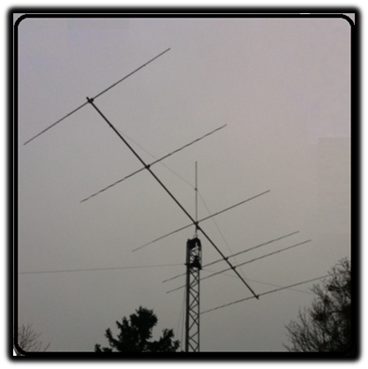
Designed by: HPSD version 1.01 Jan 2013
Boom length: 7,9 Meter
Gain: 10,32 dBI
Front to Back: < 20 dB
Impedance: 50 ohms (split element) direct fed.
SWR 1:1 : 600 Khz
SWR below 2:1 : > 1Mhz
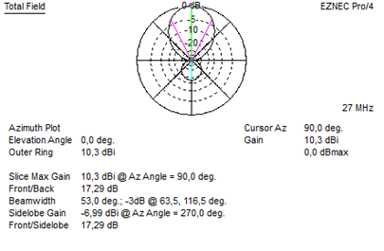
At 27 Mhz 10,3 dBI Gain and 17,3 dB front to back.

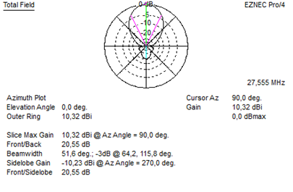
At 27,555 M hz 10,32 dBI gain and 20,55 dB front to back
At 28 Mhz 9,38 dBI gain and 17,72 dB front to back.
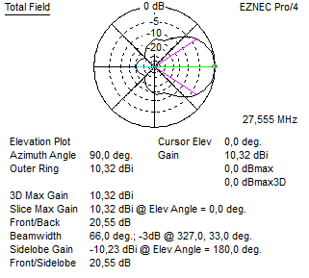
The free space elevation plot at 27,555 Mhz
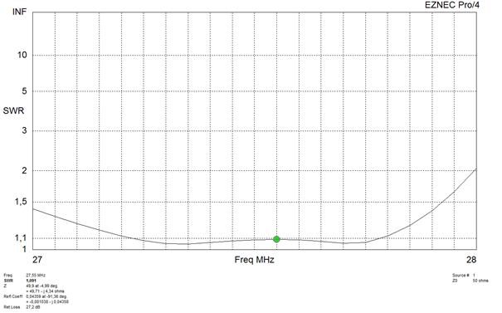
Feeding the antenna:
The antenna is 50 ohms.
The radiator (and preferbly all elements) need to be isolated from the boom. The radiator
Can be split in half and be “direct” fed.
With this said…a 1:1 balun or RF choke is adviced.
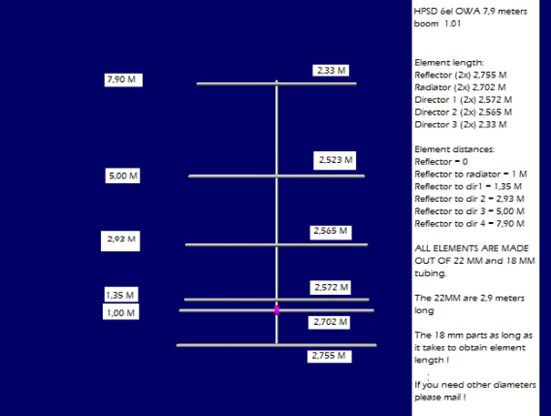
Example of element attachment.
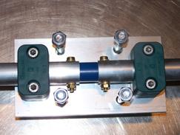
If you need any futher information, please feel free to ask.
Kind regards,
Henry HPS

